Report Manager & Ad Hoc Reporting Help

**Lydia Lim’s cheatsheet – For internal Accela use only**

Turn on *Navigation Pane* to see table of contents (Menu Bar > View > Navigation Pane)

AHR = Ad Hoc Reporting

# Adding Ad Hoc Reports to AA Reports Menu

* Ad Hoc Reports can be added to Reports menu(s) in Accela Automation just like Crystal or SSRS reports.
* This is configured through Report Manager. This cheatsheet provides help with adding Ad Hoc Reports to Report Manager.
* For detailed help with Report Manager in general, see official *Accela Automation Administrator Guide*.

# Report Service for Ad Hoc Reports - Create

* Report Manager > Settings > Report Services. Right click: New Report Service
* Example - Oakland ( av.supp.accela.com )

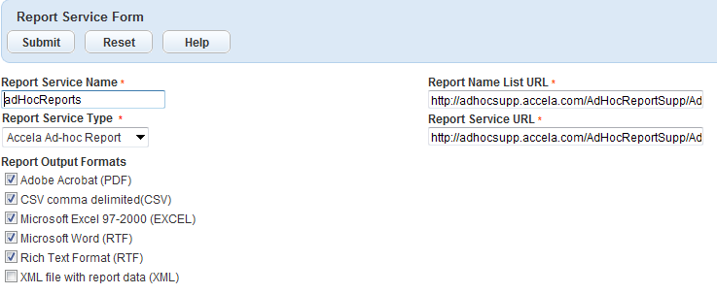

## av.supp.accela.com

Report Name List URL = <http://adhocsupp.accela.com/AdHocReportSupp/AdhocReportAdapter/FileDirectory.aspx>

Report Service URL = <http://adhocsupp.accela.com/AdHocReportSupp/AdhocReportAdapter/XReport.aspx>

(No need to specify agency. Server automatically filters for agency)

## Avtest3.accela.com

<https://utiltest3.accela.com/AdhocReport/AdhocReportAdapter/FileDirectory.aspx>

<https://utiltest3.accela.com/AdhocReport/AdhocReportAdapter/XReport.aspx>

## av3.accela.com (Production – East Coast)

* Must confirm below is correct:

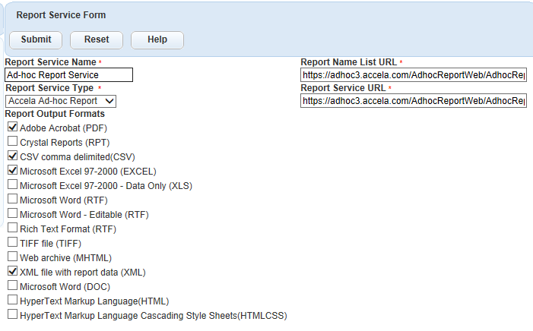

## Report Name List URL and Report Service URL

* To determine the correct Report Name List URL and Report Service URL to use in the Report Services settings for Accela Ad Hoc Reports, examine the URL at the top of the Ad Hoc Reports browser window.
  + Extract the first part of the URL including the first two folder levels.
  + For the **Report Name List URL**: add **/AdhocReportAdapter/FileDirectory.aspx** to the end.
  + For the **Report Service URL**, add /**AdhocReportAdapter/XReport.aspx** to this.
* For example:
* URL to launch Ad hoc Reporting (Oakland Production)
  + <https://adhoc1.accela.com/AdhocReportWeb/Report/Index.aspx?agency=OAKLAND&ssoId=04829451357243656902&userName=KGURNEY&module=Building&aasid=DFC70DC74309B14B61174B230A9D2358>
* Default

Report Name List URL

<http://reporting.accela.com/AdHocReport/AdhocReportAdapter/FileDirectory.aspx>

Change to:

<http://adhoc1.accela.com/AdhocReportWeb/AdhocReportAdapter/FileDirectory.aspx>

* Report Service URL default: <http://reporting.accela.com/AdHocReport/AdhocReportAdapter/XReport.aspx>

Changed to: <http://adhoc1.accela.com/AdhocReportWeb/AdhocReportAdapter/XReport.aspx>

Oakland Production Example:

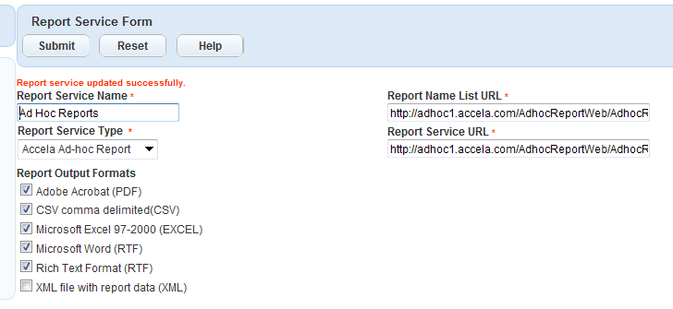

Report Picker Example:

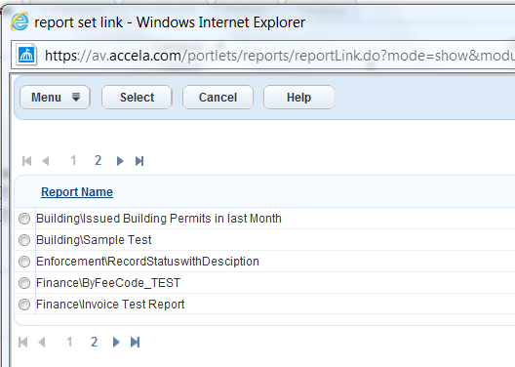

# Adding AHR Report to Report Manager

First, ensure that Ad Hoc Reporting has been added as a Report Service under Report Manager Settings. See Report Service for Ad Hoc Reports - Create

* In Report Detail tab, choose Ad Hoc Reporting process service, click on Report Link to choose report:

# Parameters

## Adding AHR Parameters to Report Manager parameter form

* You can pass parameters to an ad-hoc report using Report Manager.    Ad-Hoc reports require that the "report parameter names" in Report Manager follow a naming convention of "p1Value", "p2Value", etc...   based on the order of the parameter in the ad-hoc filter list.
  + Note: When counting the “order” to determine the # value in p#Value parameter name, skip over any filters that aren't parameters (i.e., "Param" box is not checked). See below.
* If the first parameter is a filter (Param not checked), the parameter name in Report Manager for the 2nd parameter (i.e., the first real parameter) is p1Value, not p2Value.
  + Example: The RECORD MODULE parameter should be named "p1Value" in Report Manager, not p2Value.  
    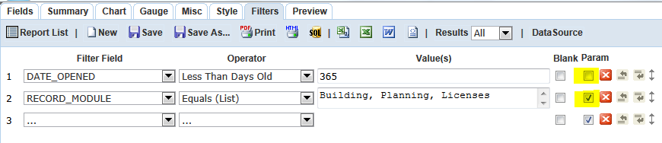
* If an AHR report parameter isn't configured in Report Manager (or if its "Report Parameter Name" is incorrect), Report Manager runs the report using the parameter values saved with the report.

## Date Range Parameters

* If an Ad Hoc Report using date range parameters must be published in Report Manager, the report’s date range parameters must be designed in a specific way. See *Ad hoc Reporting - Usage Help.docx* > FILTERS tab > Date Filters > Date Range Filters – to Work in Report Manager.

## Parameter, Equals (List)

* When the parameter accepts multiple values, i.e., the Operator is Equals (List), the parameter can be configured in Report Manager as type "Drop-down List". (Tested in IMPREF with "Records by Module LLIM" report.)  
  Example:

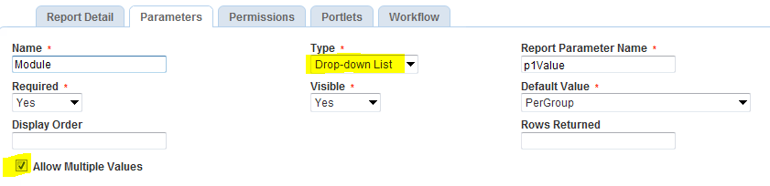

* Report Manager correctly passes the selected values as a comma-delimited list to AHR. Example:

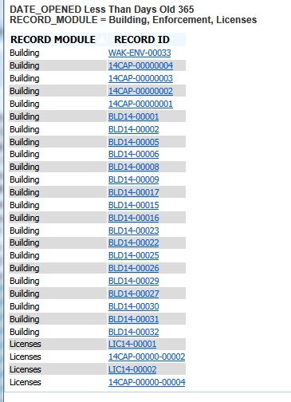

* If only a single value is selected from the dropdown, it works too:

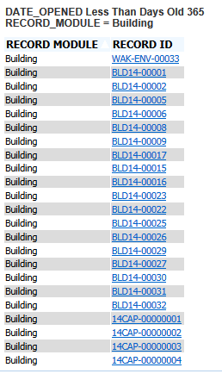

* See wiki: <http://community.accela.com/accela_automation/w/wiki/1164.filter-with-equals-list-operator-configuring-in-report-manager.aspx>

# Permissions

* Report Manager permissions for an AHR report won't override restricted *Share With* settings set for the report in AHR Tool > Misc tab. For best results, set *Share With* to “Everyone”, and control access through Report Manager permissions.

# Views

## Exposing to Ad Hoc Reporting Data Sources page

From official documentation:

Configure the Standard Choice ADHOC_REPORT_DB_VIEW to define which data sources (DB Views) are available for ad hoc reporting. If you did not configure the Standard Choice yet, Accela Automation uses a default list of DB Views. See [Standard Choices Reference](https://av.supp.accela.com/portlets-help/accelaautomationdocumentationset/docset1/accela_automation_configurers_guide/aa_ref_standard_choices/standard_choices_reference.htm#XREF_34929_Standard_Choices) for more information.

■ Open Report Manager (Settings > Ad hoc Data Sources) and assign permissions either by user group or by module for each data source. See [Setting Permissions on Ad hoc Report Data Sources](https://av.supp.accela.com/portlets-help/accelaautomationdocumentationset/docset1/aa_admin/aa_admin_report_manager/assigning_permissions_to_reports.htm#XREF_12573_Setting) for more information.

For more information*, see Ad hoc Reporting - Admin Help.docx*